Hunter Sutton

A Covid-19 Database Project 3



"I pledge that this work is entirely mine, and mine alone (except for any code provided by my instructor). "

I had no help from anyone besides the professor.

Timecard

“I spent 9 hours on this project from November 29th – December 11th reading the zyBooks, writing code, fixing errors and putting together my final document.”

**Sample Output:**

This is what was in my Entry Test and Database Test.

**Database Test**

Testing starts

[WA 6/30 902 infections 10 deaths, WA 7/1 878 infections 12 deaths, WA 7/2 869 infections 7 deaths, WA 7/3 443 infections 3 deaths, WA 7/4 231 infections 10 deaths]

[TX 6/12 2,097 infections 19 deaths, NC 6/12 1,768 infections 28 deaths, FL 6/12 1,902 infections 29 deaths, CA 6/12 2,702 infections 62 deaths, AZ 6/12 1,654 infections 17 deaths]

Testing ends

**Entry Test**

Testing starts

MI 5/4 1,000 infections 2,000 deaths

Testing ends

**Screenshot of CovidEntryJUnit and CovidDatabaseJUnit Test showing what I passed.**

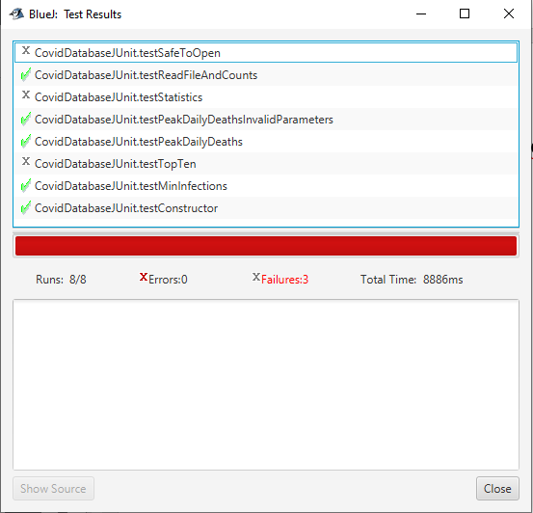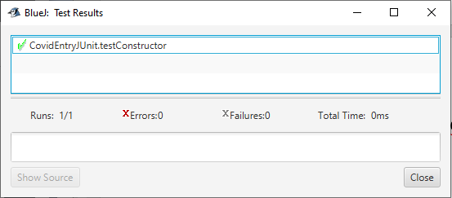

**Screenshots of The GUI working.**

I unfortunatly could not get my GUI to work, this I think is parcially because of my errors in the database class.